**STUDENT INFORMATION SYSTEM**

***Team No:25***

# ***Abstract:***

A student information system (SIS) is a software application designed to manage and organize student-related data within educational institutions. It typically includes features such as student registration, attendance tracking, grade management, course scheduling, and administrative functions like generating reports and managing student records. SISs play a crucial role in streamlining administrative processes, enhancing communication between students, teachers, and administrators, and improving overall efficiency within educational institutions.

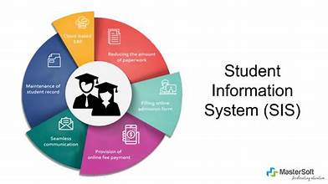

# ***Introduction:***

An SIS, short for **Student Information System**, is a specialized **software application** designed to manage student-related data within educational institutions. [It serves as a core system of record (SOR) for higher education institutions, supporting both routine administrative tasks and academic activities1](https://www.softwareadvice.com/resources/what-is-a-student-information-system/). Here are some key points about SIS:

1. **Purpose and Functionality:**
   * An SIS centralizes student data, making it easier for educational institutions to manage information related to students.
   * It handles various aspects of student records, including academic performance, personal details, and financial data.
   * For smaller educational institutes, an SIS streamlines administrative tasks that traditionally involved manual processes, freeing up staff to focus on other responsibilities.
   * Examples of SIS functions include student registration, grade management, attendance tracking, and transcript creation.
2. **Benefits of Using an SIS:**
   * **Centralized Repository:** An SIS provides a single source of truth for student data. Staff members can access necessary information quickly without searching through multiple systems or databases.
   * **Reduced Errors:** Since data is entered only once and shared across the system, it minimizes errors and enhances data accuracy.
   * **Efficiency:** SIS streamlines processes, allowing institutions to handle student-related tasks more efficiently.

**Functional Requirements:**

The **functional requirements** for a **Student Information System (SIS)**. These requirements define the system’s capabilities and features. Here are some key functionalities that an SIS should have:

1. **Student Registration and Admission:**
   * The system should allow students to register for courses, providing essential personal information and academic preferences.
   * It should manage the admission process, including verifying eligibility criteria and collecting necessary documents.
2. **Enrollment Management:**
   * The SIS must handle course enrollment, allowing students to select their preferred subjects or courses during registration.
   * It should track student enrollment in specific semesters or academic terms.
3. **Attendance Tracking:**
   * The system should record student attendance in classes, labs, and other academic activities.
   * Faculty members can input attendance data, and students can view their attendance records.
4. **Grade Management:**
   * The SIS must manage student grades and examination marks.
   * Faculty members should be able to enter grades, and students can access their results.
5. **Student Records:**
   * The system should maintain accurate student records, including personal details, contact information, and academic history.
   * It should generate transcripts and other official documents.
6. **Communication Tools:**
   * An SIS should facilitate communication between students, faculty, and administrators.
   * Features like announcements, notifications, and messaging can enhance communication within the educational institution.

***ER Diagram:***

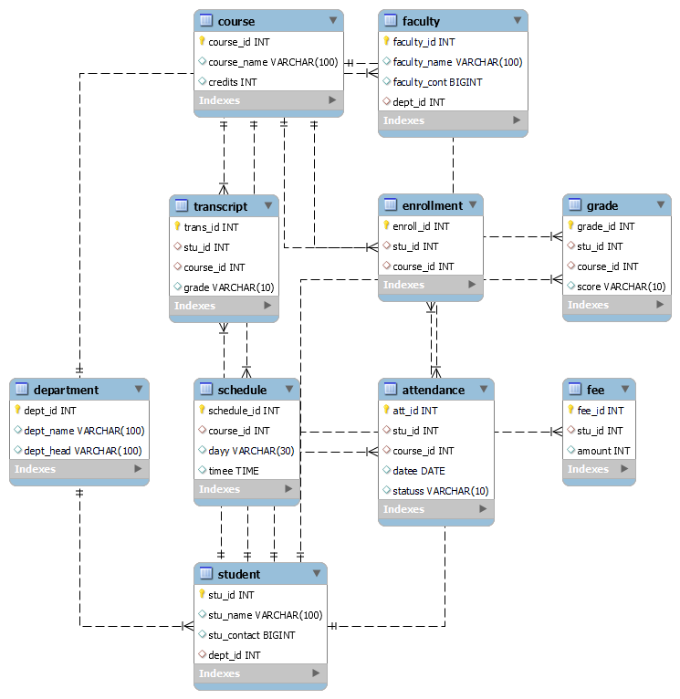

# **Quries to create Database:**

create database db;

use db;

create table department(dept_id int not null primary key,dept_name varchar(100),dept_head varchar(100));

create table course(course_id int not null primary key,course_name varchar(100),credits int);

create table student(stu_id int not null primary key,stu_name varchar(100),stu_contact bigint,dept_id int, foreign key(dept_id) references department(dept_id));

create table faculty(faculty_id int not null primary key,faculty_name varchar(100),faculty_cont bigint,dept_id int,foreign key(dept_id) references department(dept_id));

create table enrollment(enroll_id int not null primary key,stu_id int,foreign key(stu_id) references student(stu_id),course_id int,foreign key(course_id) references course(course_id));

create table fee(fee_id int not null primary key,stu_id int,foreign key(stu_id) references student(stu_id),amount int);

create table schedule(schedule_id int not null primary key,course_id int,foreign key(course_id) references course(course_id),dayy varchar(30),timee time);

create table attendance(att_id int not null primary key,stu_id int,foreign key(stu_id) references student(stu_id),course_id int,foreign key(course_id) references course(course_id),datee date,statuss varchar(10));

create table grade(grade_id int not null primary key,stu_id int,foreign key(stu_id) references student(stu_id),course_id int,foreign key(course_id) references course(course_id),score varchar(10));

create table transcript(trans_id int not null primary key,stu_id int,foreign key(stu_id) references student(stu_id),course_id int,foreign key(course_id) references course(course_id),grade varchar(10));

**UML Diagram of Student Information:**

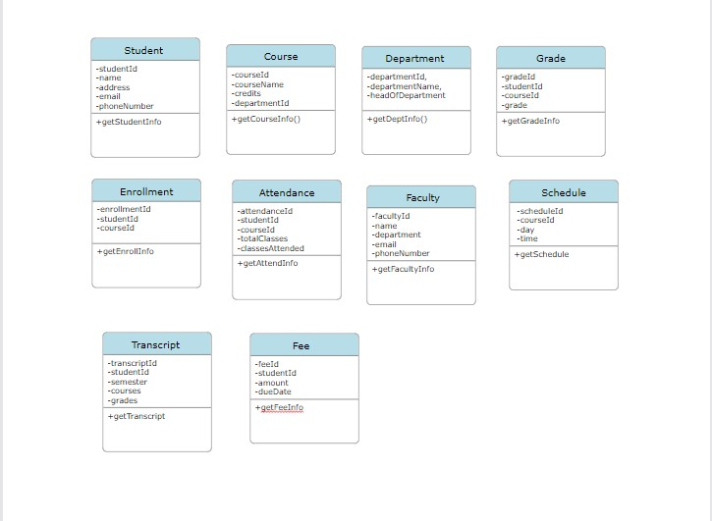

**ALL JAVA FILES CODES:**

**Package:** studentInfoSystem;

**Student class:**

package studentInfoSystem;

public class Student {

    String studentId;

    String studentName;

    String studentContact;

    String departmentId;

    public Student(String studentId, String studentName, String studentContact,String departmentId) {

        this.studentId = studentId;

        this.studentName = studentName;

        this.studentContact = studentContact;

        this.departmentId=departmentId;

    }

    public String getStudentId() {

        return studentId;

    }

    public void setStudentId(String studentId) {

        this.studentId = studentId;

    }

    public String getStudentName() {

        return studentName;

    }

    public void setStudentName(String studentName) {

        this.studentName = studentName;

    }

    public String getStudentContact() {

        return studentContact;

    }

    public void setStudentContact(String studentContact) {

        this.studentContact = studentContact;

    }

    public String getDepartmentId() {

        return departmentId;

    }

    public void setDepartmentId(String departmentId) {

        this.departmentId = departmentId;

    }

    public void display() {

        System.out.println("Student ID: " + studentId);

        System.out.println("Student Name: " + studentName);

        System.out.println("Student ContactNo: " + studentContact);

        System.out.println("Student departmentId: " + departmentId);

    }

}

***Course class:***

package studentInfoSystem;

public class Course {

    String courseId;

    String courseName;

    int credits;

    public Course(String courseId, String courseName, int credits) {

        this.courseId = courseId;

        this.courseName = courseName;

        this.credits = credits;

    }

    public String getCourseId() {

        return courseId;

    }

    public void setCourseId(String courseId) {

        this.courseId = courseId;

    }

    public String getCourseName() {

        return courseName;

    }

    public void setCourseName(String courseName) {

        this.courseName = courseName;

    }

    public int getCredits() {

        return credits;

    }

    public void setCredits(int credits) {

        this.credits = credits;

    }

    public void display() {

        System.out.println("Course ID: " + courseId);

        System.out.println("Course Name: " + courseName);

        System.out.println("Credits: " + credits);

    }

}

***Department class:***

package studentInfoSystem;

public class Department {

    String departmentId;

    String departmentName;

    String department_head;

    public Department(String departmentId, String departmentName, String department_head) {

        this.departmentId = departmentId;

        this.departmentName = departmentName;

        this.department_head=department_head;

    }

    public String getDepartmentId() {

        return departmentId;

    }

    public void setDepartmentId(String departmentId) {

        this.departmentId = departmentId;

    }

    public String getDepartmentName() {

        return departmentName;

    }

    public void setDepartmentName(String departmentName) {

        this.departmentName = departmentName;

    }

    public String getDepartment_head() {

        return department_head;

    }

    public void setDepartment_head(String department_head) {

        this.department_head = department_head;

    }

    public void display() {

        System.out.println("Department ID: " + departmentId);

        System.out.println("Department Name: " + departmentName);

        System.out.println("Head of the department: " +department_head);

    }

}

***Attendance class:***

package studentInfoSystem;

public class Attendance {

    int attendance_id;

    String student_id;

    String course_id;

    String date;

    String status;

    public Attendance( int attendance_id,String student_id,String course_id ,String date,String status) {

        this.attendance_id = attendance_id;

        this.student_id = student_id;

        this.course_id = course_id;

        this.date=date;

        this.status=status;

    }

    public int getAttendance_id() {

        return attendance_id;

    }

    public void setAttendance_id(int attendance_id) {

        this.attendance_id = attendance_id;

    }

    public String getStudent_id() {

        return student_id;

    }

    public void setStudent_id(String student_id) {

        this.student_id = student_id;

    }

    public String getCourse_id() {

        return course_id;

    }

    public void setCourse_id(String course_id) {

        this.course_id = course_id;

    }

    public String getDate() {

        return date;

    }

    public void setDate(String date) {

        this.date = date;

    }

    public String getStatus() {

        return status;

    }

    public void setStatus(String status) {

        this.status = status;

    }

    public void display() {

        System.out.println("Attendance_id:"+attendance_id);

        System.out.println("student id:"+student_id);

        System.out.println("course id:"+course_id);

        System.out.println("Status: " + status);

        System.out.println("Date: " + date);

    }

}

***Enrollment class:***

package studentInfoSystem;

public class Enrollment {

    int student_id;

    int enrollment_id;

    String course_id;

    public Enrollment(int student_id,String course_id,int enrollment_id) {

        this.student_id = student_id;

        this.course_id= course_id;

        this.enrollment_id = enrollment_id;

    }

    public int getStudent_id() {

        return student_id;

    }

    public void setStudent_id(int student_id) {

        this.student_id = student_id;

    }

    public int getEnrollment_id() {

        return enrollment_id;

    }

    public void setEnrollment_id(int enrollment_id) {

        this.enrollment_id = enrollment_id;

    }

    public String getCourse_id() {

        return course_id;

    }

    public void setCourse_id(String course_id) {

        this.course_id = course_id;

    }

    public void display() {

        System.out.println("Enrollment_id:"+enrollment_id);

        System.out.println("Enter the course ID"+course_id);

        System.out.println("Student_id: " + student_id);

    }

}

***Faculty class:***

package studentInfoSystem;

public class Faculty {

    String facultyId;

    String facultyName;

    String facultyContact;

    String departmentId;

    public Faculty(String facultyId, String facultyName, String departmentId, String facultyContact) {

        this.facultyId = facultyId;

        this.facultyName = facultyName;

        this.departmentId = departmentId;

        this.facultyContact=facultyContact;

    }

    public void display() {

        System.out.println("Faculty ID: " + facultyId);

        System.out.println("Faculty Name: " + facultyName);

        System.out.println("Faculty Contact: " +facultyContact);

        System.out.println("DepartmentID: " + departmentId);

    }

}

***Fee class:***

package studentInfoSystem;

public class Faculty {

    String facultyId;

    String facultyName;

    String facultyContact;

    String departmentId;

    public Faculty(String facultyId, String facultyName, String departmentId, String facultyContact) {

        this.facultyId = facultyId;

        this.facultyName = facultyName;

        this.departmentId = departmentId;

        this.facultyContact=facultyContact;

    }

    public void display() {

        System.out.println("Faculty ID: " + facultyId);

        System.out.println("Faculty Name: " + facultyName);

        System.out.println("Faculty Contact: " +facultyContact);

        System.out.println("DepartmentID: " + departmentId);

    }

}

***Grade class:***

package studentInfoSystem;

public class Grade {

    String student_id;

    int grade_id;

    String course_id;

    String score;

    public Grade(String student_id, int grade_id, String course_id, String score) {

        this.student_id = student_id;

        this.grade_id = grade_id;

        this.course_id = course_id;

        this.score=score;

    }

    public String getStudent_id() {

        return student_id;

    }

    public void setStudent_id(String student_id) {

        this.student_id = student_id;

    }

    public int getGrade_id() {

        return grade_id;

    }

    public void setGrade_id(int grade_id) {

        this.grade_id = grade_id;

    }

    public String getCourse_id() {

        return course_id;

    }

    public void setCourse_id(String course_id) {

        this.course_id = course_id;

    }

    public String getScore() {

        return score;

    }

    public void setScore(String score) {

        this.score = score;

    }

    public void display() {

        System.out.println("student id:"+student_id);

        System.out.println("Grade:"+grade_id);

        System.out.println("course id:"+course_id);

        System.out.println("score: " + score);

    }

}

***Schedule class:***

package studentInfoSystem;

public class Schedule {

    String scheduleId;

    String course;

    String day;

    String time;

    public Schedule(String scheduleId,String course, String day, String time) {

        this.scheduleId=scheduleId;

        this.course = course;

        this.day = day;

        this.time = time;

    }

    public String getScheduleId() {

        return scheduleId;

    }

    public void setScheduleId(String scheduleId) {

        this.scheduleId = scheduleId;

    }

    public String getCourse() {

        return course;

    }

    public void setCourse(String course) {

        this.course = course;

    }

    public String getDay() {

        return day;

    }

    public void setDay(String day) {

        this.day = day;

    }

    public String getTime() {

        return time;

    }

    public void setTime(String time) {

        this.time = time;

    }

    public void display() {

        System.out.println("Schedule_id:"+scheduleId);

        System.out.println("course:"+course);

        System.out.println("Day: " + day);

        System.out.println("Time: " + time);

    }

}

***Transcription class:***

package studentInfoSystem;

public class Transcription {

    String student_id;

    String course_id;

    int grade;

    int transcript_id;

    public Transcription(String student_id, String course_id, int transcript_id,int grade) {

        this.student_id = student_id;

        this.course_id = course_id;

        this.grade = grade;

        this.transcript_id=transcript_id;

    }

    public String getStudent_id() {

        return student_id;

    }

    public void setStudent_id(String student_id) {

        this.student_id = student_id;

    }

    public String getCourse_id() {

        return course_id;

    }

    public void setCourse_id(String course_id) {

        this.course_id = course_id;

    }

    public int getGrade() {

        return grade;

    }

    public void setGrade(int grade) {

        this.grade = grade;

    }

    public int getTranscript_id() {

        return transcript_id;

    }

    public void setTranscript_id(int transcript_id) {

        this.transcript_id = transcript_id;

    }

    public void display() {

        System.out.println("student id :"+student_id);

        System.out.println("course id:"+course_id);

        System.out.println("grade id:"+grade);

        System.out.println("Transcript:"+transcript_id);

    }

}

# ***Main Class:***

package studentInfoSystem;

import java.util.Scanner;

import java.io.*;

import java.lang.*;

public class Main {

    public static void main(String args[]) {

        Scanner sc=new Scanner(System.in);

        //department

        System.out.println("Enter department id");

        String id=sc.nextLine();

        System.out.println("Enter department name");

        String name=sc.nextLine();

        System.out.println("Enter name of the HOD");

        String hName=sc.nextLine();

        Department d=new Department(id,name,hName);

        d.display();

        //course

         System.out.println("Enter course ID:");

         String courseId = sc.nextLine();

         System.out.println("Enter course name:");

         String courseName = sc.nextLine();

         System.out.println("Enter credits:");

         int credits = sc.nextInt();

         sc.nextLine();

         Course c= new Course(courseId, courseName, credits);

         c.display();

         //student

         System.out.println("Enter student ID:");

         String studentId = sc.nextLine();

         System.out.println("Enter student name:");

         String studentName = sc.nextLine();

         System.out.println("Enter student contact:");

         String studentContact = sc.nextLine();

         System.out.println("Enter department ID:");

         String departmentId = sc.nextLine();

         Student s = new Student(studentId, studentName, studentContact, departmentId);

         s.display();

         //faculty

         System.out.println("Enter faculty ID:");

         String facultyId = sc.nextLine();

         System.out.println("Enter faculty name:");

         String facultyName = sc.nextLine();

         System.out.println("Enter faculty contact:");

         String facultyContact = sc.nextLine();

         System.out.println("Enter department ID:");

         String departmentIdd = sc.nextLine();

         Faculty f = new Faculty(facultyId, facultyName, facultyContact, departmentIdd);

         f.display();

         //enrollment

         System.out.println("Enter student ID:");

         int student_id = sc.nextInt();

         System.out.println("Enter enrollment ID:");

         int enrollment_id = sc.nextInt();

         sc.nextLine();

         System.out.println("Enter course ID:");

         String course_id = sc.nextLine();

         Enrollment enrollment = new Enrollment(student_id, course_id, enrollment_id);

         enrollment.display();

         //fee

         System.out.println("Enter student ID:");

         String students_id = sc.nextLine();

         System.out.println("Enter amount:");

         double amount = sc.nextDouble();

         sc.nextLine();

         System.out.println("Enter fee ID:");

         String fee_id = sc.nextLine();

         Fee fee = new Fee(students_id, amount, fee_id);

         fee.display();

         //schedule

         System.out.println("Enter schedule ID:");

         String sid=sc.nextLine();

         String ca=courseName;

         System.out.println("Enter day:");

         String day=sc.nextLine();

         System.out.println("Enter time:");

         String time=sc.nextLine();

         Schedule sch=new Schedule(sid,ca,day,time);

         sch.display();

         //attendance

         System.out.println("Enter attendance id:");

         int att_id=sc.nextInt();

         sc.nextLine();

         String ssid=studentId;

         String cid=courseId;

         System.out.println("Enter date:");

         String date=sc.nextLine();

         System.out.println("Enter status:");

         String status=sc.nextLine();

         Attendance atten=new Attendance(att_id,ssid,cid,date,status);

         atten.display();

         //grade

         String stu_id=studentId;

         System.out.println("Enter grade id:");

         int gid=sc.nextInt();

         sc.nextLine();

         String cou_id=courseId;

         System.out.println("Enter score:");

         String score=sc.nextLine();

         Grade g=new Grade(stu_id,gid,cou_id,score);

         g.display();

         //transcript

         String stud_id=studentId;

         String cour_id=courseId;

         int gra_id=gid;

         System.out.println("Enter transcript id:");

         int trans_id=sc.nextInt();

         Transcription transcrpt=new Transcription(stud_id,cour_id,trans_id,gra_id);

         transcrpt.display();

    }

}

# ***Challenges List:***

Implementing and maintaining a **Student Information System (SIS)** comes with its fair share of challenges. Let’s explore some of these challenges and discuss potential solutions:

1. **Data Security**:
   * **Challenge**: SIS tools contain sensitive student data, including personal information, academic records, and financial aid details. [Ensuring data security is crucial to protect against cyber threats and unauthorized access1](https://studentinformationsystem.co.in/blog/challenges-in-implementing-and-maintaining-sis.aspx).
   * **Solution**: Implement robust security measures, including encryption, access controls, regular security audits, and user authentication protocols. Regularly update security practices to stay ahead of evolving threats.
2. **Cost**:
   * **Challenge**: Implementing an SIS can be expensive, especially for smaller educational institutions with limited budgets. [Costs include software licenses, hardware infrastructure, training, and ongoing maintenance](https://studentinformationsystem.co.in/blog/challenges-in-implementing-and-maintaining-sis.aspx).
   * **Solution**: Evaluate cost-effective SIS options, consider cloud-based solutions, and explore open-source alternatives. Prioritize essential features to avoid unnecessary expenses.
3. **Implementation Time**:
   * **Challenge**: Getting an SIS up and running can take time, affecting administrative processes and student services. [Delays may occur due to customization, data migration, and staff training](https://studentinformationsystem.co.in/blog/challenges-in-implementing-and-maintaining-sis.aspx)[1](https://studentinformationsystem.co.in/blog/challenges-in-implementing-and-maintaining-sis.aspx).
   * **Solution**: Plan the implementation process meticulously, allocate sufficient resources, and involve key stakeholders early. Consider phased rollouts to minimize disruptions.